Karnataka Valuation & E-Registration (KAVERI - 2.0)
Government of Karnataka

Functional Requirement Specifications

For KAVERI 2.0
Department of Stamps & Registration
Government of Karnataka
___________________

PAN AUTHENTICATION

Prepared by
Centre for Smart Governance (CSG)
2nd Floor, TTMC Yeshwanthapura, BMTC Bus station
Bangalore – 3060022
Contents
Acronyms 3
Revision History 3
1. Introduction 4
2. Document scope 4
3. Overview of the function 5
4. Functional Requirements 7
4.1 Application Submission 7
4.2 Scrutiny 7
4.3 Presentation and Registration 7
4.4 Activity Diagram: Pan Authentication 8
5. Input validations 9
6. External integration 9
7. Assumptions and Dependencies 9
7.1. Assumptions 9
7.2. Dependencies 9
8. Limitation 9
Annexure – 1: List of modules of Kaveri 2.0 10
Annexure – 2: Actors and Responsibilities 11
Annexure – 3: Requirements as shared by the department 12
Annexure – 4: Scenarios 13
Annexure-5: Sample payload & Response of Protean PAN API 13

Acronyms
API | Application Programming Interface
CSG | Centre for Smart Governance
CV | Consideration Valuation
MV | Market Valuation
OTP | One-time password
PAN | Permanent Account Number
POI | Proof of Identity
SR | Sub-Registrar
SRO | Sub-Registrar Office

Revision History
Date | Version | Prepared by | Reviewed By | Approved By | Description
23-10-2025 | 1.0 | Yash Veer

Introduction
The Department of Stamps and Registration (henceforth referred to as “department”) is the custodian of registered public records such as Registration of Marriages and Firms, Documents pertaining to transactions, namely sale, transfer or gift of immovable properties, mortgages, power of attorney, wills and many more. Maintenance and preservation of these critical public records is the prime responsibility of the department. The records or the information associated with registered records are to be made available to the public when requested through defined procedures. The department is also responsible for collecting stamp duty on behalf of the Government for specified transactions. The services are provided through 259 Sub-Registrar Offices (SROs), under the supervision of 34 District Registrar Offices, spread across the state.
The department has computerised the delivery of these services through the development of Kaveri software. KAVERI Online service is a web-based application of the department which provides an interface to the applicants required for documents, marriage and firm registration. It enables applicants to know the details of stamp duty, property guideline value, data entry for document registration and marriage registration, etc. The list of modules of Kaveri 2.0 is available in Annexure 1.

Document scope
This document is a Functional Requirement Specification (FRS) describing the functional features of the PAN Authentication in document registration via Kaveri 2.0. The document is prepared by the Centre for Smart Governance (CSG) and has been approved by the department. The intended audience of the document is the departmental approving authority and the development team.

Overview of the function
- The overall workflow of PAN authentication will involve the following changes in the ordering of the key steps.

- In the proposed function, PAN details will be verified in real time at all stages through the integration of a PAN API.
- Aside from the sequence of the aforementioned steps, the key changes are outlined as follows, with further elaboration provided in the subsequent sections.
Application phase | Key changes
Application Submission | - Integration of PAN authentication API at the party info screen to verify PAN details in real-time.  - During fee calculation:  - If MV or CV is less than 30L, the applicant does not need to authenticate PAN.  - If MV or CV is ≥ INR 30L for any one property among the selected properties, the applicant should provide PAN details for all the executants (including claimants).  - Applicant should authenticate PAN details if SR returns the application with increased MV or CV (≥ 30L).  - If PAN is not available, the applicant should fill out forms 60 & 61 and e-sign or manually sign and upload the documents.
Scrutiny | - During scrutiny, if MV or CV is ≥ INR 30L for any one property among the selected properties, SR will send back the application to the applicant to verify the PAN.  - SR can view the verified PAN details during scrutiny if available.
Payment | - No changes
Appointment | - No changes
Presentation & Registration | - Display name as per PAN both in the applicant and department summary document

Functional Requirements

4.1 Application Submission
- On the Party Info page of the KAVERI portal, executants can choose any of the identity-proof options like Aadhaar, passport or PAN.
- When the user selects PAN as POI and clicks “Verify PAN”, KAVERI’s 2.0 shall allow the user to enter:
- PAN number
- Name as per PAN
- Father's name
- DOB and send this payload for the third-party API verification.
- The API shall return the result, and KAVERI displays a “Details as per PAN API ” on success.
- The fetched details will be stored in the database and can be used at a later stage of the application.
- If the Market or the consideration value is less than INR 30 lakhs, the user will be allowed to submit the application for scrutiny.
- When the market or consideration value is equal to or more than INR 30 Lakhs:
- If all the executants’ PAN Details have already been verified earlier in the party info page, then the user can proceed further.
- Else, the user enters PAN details and clicks on the ‘Verify’ button, the system shall validate the PAN details.
- If the user does not have PAN, the system should generate Form 60 & 61.
- The system presents the user with the option to e-sign or manually sign and upload Form 60/61.

4.2 Scrutiny
- SR receives the application for the pre-scrutiny and evaluates MV or CV:
- During scrutiny, if SR valuation of MV or CV is ≥ INR 30L for any one property among the selected properties, SR sends back the application to the applicant to verify the PAN.
- If MV or CV is less than INR 30L, the application follows the existing flow.

4.3 Presentation and Registration
- SR should be able to view PAN details or form 60&61 if available with verification status.
- The summary document will have the name as per PAN and verification status.
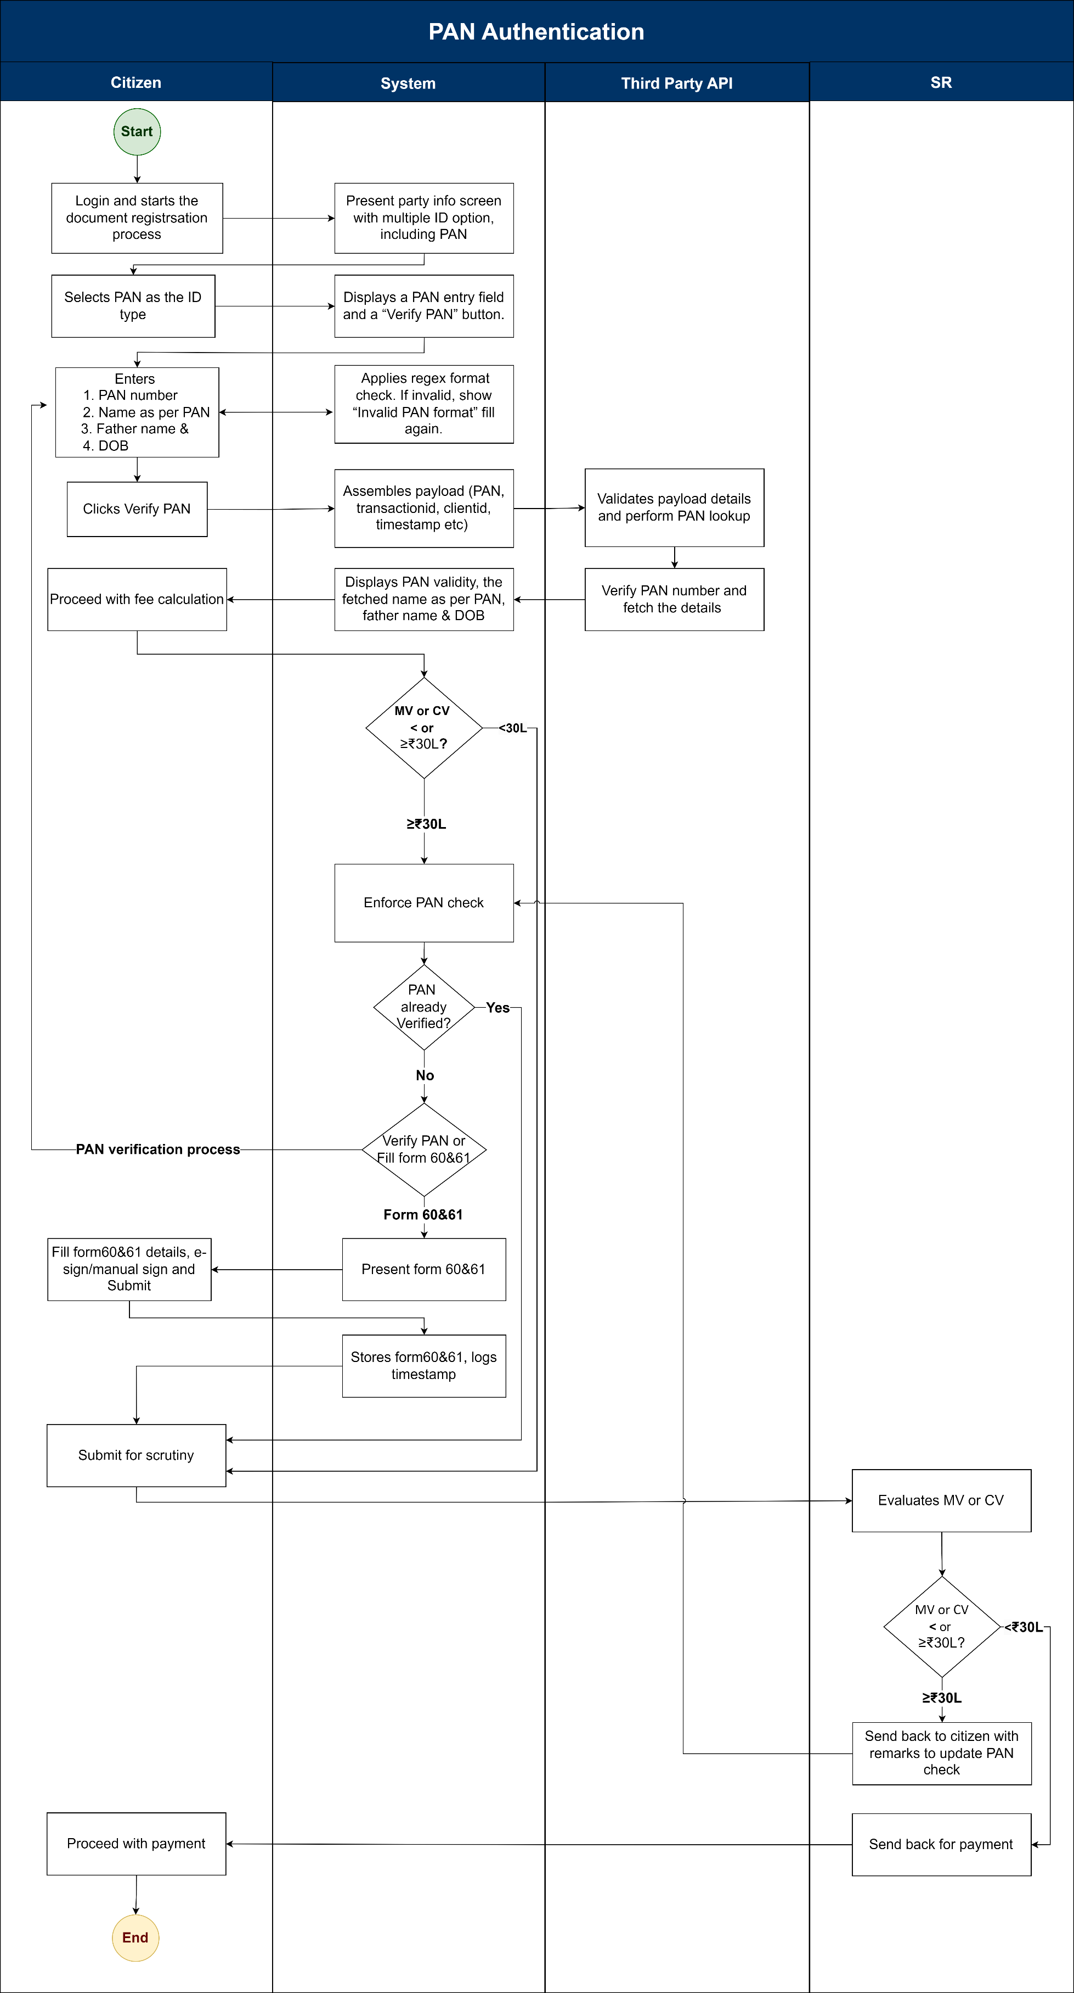

4.4 Activity Diagram: Pan Authentication

Input validations
- PAN Number format check

External integration
- This module has an integration with the external system API to verify and validate the applicant's PAN authenticity at the party info screen and fee calculation screen.
- Existing integrations like K2, Aadhaar, etc, remain the same.

Assumptions and Dependencies

Assumptions
- PAN API will verify the PAN number and display the name as per the PAN.
- Name as per the property masters and name retrieved from PAN should be scrutinised by the SR.

Dependencies
- This feature has a dependency on the third-party PAN database.

Limitation
- The system will not allow the user to make the payment until the PAN details are verified or the Form 60 & 61 are signed using an Aadhar-based e-sign, when the market value or the consideration value is equal to or more than INR 30 Lakhs.
- If the PAN API is not working, application submission will not be possible in case if the applicant wants to choose PAN as POI or MV/CV is more than INR 30Lakhs.

Annexure – 1: List of modules of Kaveri 2.0
Sl. No | Module No | Main Module | Sub-Module
1 | 1.1 | Registration | Registration
2 | 1.2 | Registration | Appointment
3 | 1.3 | Registration | Integration module
4 | 1.4 | Registration | Stamp duty and Registration fee calculation
30 | 1.30 | Registration | Guideline value calculation
6 | 1.6 | Registration | Rule 17 (2) filing
7 | 1.7 | Registration | Rule 17 (3) filing
8 | 1.8 | Registration | Old pending release module
9 | 1.9 | Registration | Re-Registration module
10 | 1.1 | Registration | Will after Death
11 | 1.11 | Registration | Filing documents (FRUITS)
12 | 1.12 | Registration | Scanning
13 | 1.13 | Registration | Memo transmission and filing
14 | 1.14 | Registration | 68(2) correction
130 | 1.130 | Registration | Cross-reference Rule 123
16 | 1.16 | Registration | Integration exemption
17 | 1.17 | Registration | Court entry
18 | 1.18 | Registration | Liability
19 | 1.19 | Registration | Status tracking
20 | 1.2 | Registration | Investigation and Search
21 | 1.21 | Registration | Valuation Module (CVC)
22 | 2 | EC
23 | 3 | CC
24 | 4 | Verify Document
230 | 30 | Power of attorney Authentication Module
26 | 6 | Refund Module
27 | 7.1 | Marriage | Hindu Marriage
28 | 7.2 | Marriage | Special Marriage
29 | 7.3 | Marriage | Special Marriage in Other forms
30 | 8 | Legacy record digitisation
31 | 9 | Audit
32 | 10 | Accounts
33 | 11.1 | MIS | Statutory (44)
34 | 11.2 | MIS | Statistical (304)
330 | 11.3 | MIS | Integration (130)
36 | 11.4 | MIS | Computer related (4)
37 | 11.30 | MIS | Reconciliation (30)
38 | 11.6 | MIS | HR (30)
39 | 12.1 | DRO | Firm Registration
40 | 12.2 | DRO | Undervaluation
41 | 12.3 | DRO | Deposit of will
42 | 12.4 | DRO | Adjudication of documents
43 | 13 | IGRO | Appeal
44 | 14 | Master Data Management
430 | 130 | User Management
46 | 16 | Mobile application
47 | 17 | Training Module | Master Trainer, Training Plan

Annexure – 2: Actors and Responsibilities

Actors | Responsibilities
Applicant | - Select PAN as POI and verify PAN at the party info screen.  - In case a applicant doesn’t have a PAN, they should fill form 60 and 61 & E-sign or manually sign the form and upload the copies.  - Continue and make the payment.
SR | - SR scrutiny.  - After receiving the application, SR verifies the application details and allocates for biometric captures.
DEO | - Transmit the summary to the SR  - Summary will have name as per PAN.  - Scan and upload the signed document for a digital scan.
System | - Check if the market or consideration value, whichever is equal to or more than INR 30L to be paid.  - Should not allow the applicant to make the payment until the user validates all the executants' PAN or Form 60 and 61.  - Do the first-level format check when the applicant enters the PAN number  - Checks the availability of the PAN with the third-party PAN API.  - Prompt form 60 & 61 in case of unavailability of PAN  - Displays consent to proceed with payment.
Process Triggers | - Applicant selects PAN as the proof of identity at the party info screen.  - Upon entering the PAN clicks on the verify button to authenticate the PAN details.  - In case PAN is not available applicant to click on fill form 60 & 61 and then E-sign.  - Applicant verifies the PAN of all executants to complete the payment.
Data/Information Required | - PAN number.  - Form 60 & 61.
Output documents generated | - Payment receipt.  - In both the applicant and the department summary, below the executant's name as per PAN should be displayed.
Internal changes | - PAN validation step will be added on the applicant side.  - Executants' list who had submitted PAN/form60&61 to be displayed at the SR side in step 5.
Impact on other modules | - NA

Annexure – 3: Requirements as shared by the department

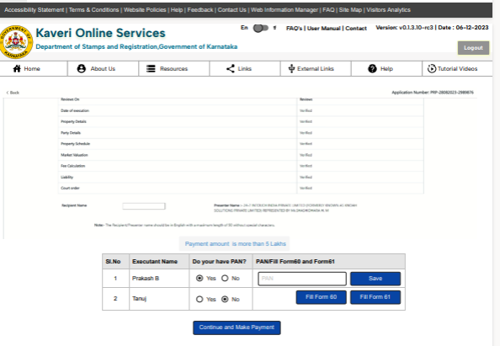

Annexure – 4: Scenarios
Sl. No. | Market value or Consideration. | Is PAN Mandatory | PAN is available for all executants | Description | Expected Outcome
1 | < 30 Lakhs | No | NA | The user is allowed to make the payment | Navigate to Khajane 2
2 | >= 30 Lakhs | Yes | Yes | All the executants have PAN details, and all the PAN details are successfully verified. Should be allowed for the payment. | Navigate to Khajane 2
3 | >= 30 Lakhs | Yes | No | When one or more executants do not have the PAN details. Fills and E-Signs or Ink sign on Form 60 & 61. Should be allowed for payment. | Navigate to Khajane 2
4 | >= 30 Lakhs | Yes | Yes | When PAN Authentication fails or the API times out during the verification. | Display the following error message: “Please verify the PAN after 5 minutes”.
5 | >= 30 Lakhs | Yes | Yes | When E-Sign is unsuccessful on forms 60 & 61. | Should display a message “Please try again”
6 | >= 30 Lakhs | Yes | Yes | When any of the executants doesn’t want to verify the PAN. | Shouldn’t proceed until the PAN is verified.

Annexure-5: Sample payload & Response of Protean PAN API
JSON Request Prototype:
Payload: { " inputData" : [ {“pan”:"",“name”:"",“fathername”:"",“dob”:""}, . . . . ]
"signatre":" “ }
JSON Response Prototype:
Response : { " response_Code" : "", "outputData" : [ {" pan":""," pan_status":""," name":"","fathername":"",“dob”:"","seeding_status":""}, . . . . ] }

An executant enters a PAN number into the KAVERI system, and the API returns a “Match” for the PAN and display name as per PAN. Technically, this verifies that the PAN number exists. But—how do we know that this PAN actually belongs to this person?
Where will an executant enter a PAN number, on Kaveri party-info step or on the third-party screen? And what detail can be fetched from the PAN API?

